Dear All,
It has been a while since we last gave you an update of how we’re doing here in Makeni. We hope and pray that you have started the year well.

Here in Makeni we were all very optimistic when the country started to record lower numbers of new cases and this trend has continued over the last couple of months countrywide. There are now four districts that have had no positive cases recorded for over the official 42 days. There are four other districts that now have 21 days with no new cases reported. They’re hoping to reach the 42 days as well. Unfortunately Bombali, where we live, is one of the six districts still struggling to get the new infection numbers down to nil but often it lasts for only a few days. The reason for all this is that people continue to move sick people out of the hotspot areas for native treatment. Families are still insisting on hiding the sick and involving traditional healers which is aiding the spread of the virus. Experts say that this pattern of troughs and spikes could continue to happen up to the end of August before we see an end to the new cases according to the chairperson of WHO. We hope this is the case because according to the latest reports, Sierra Leone has reported the lowest number of new cases for the first time since June 2014. The Government has decided that the whole country will now go into lock down for another three days from the 27th to the 29th March with a short break on Sunday between 7am and 2pm for Christians to attend Palm Sunday services and on Friday between 12pm. This will then be followed by the next three Saturdays of lock down when there will be no activities or trading between 6am and 6pm. This is the Government’s campaign to make sure that they get to zero infections in the next few weeks.

The President announced the reopening of schools and institutions and it has been decided that the higher education institutions will reopen on the 30th of March while the primary and secondary schools will reopen on the 14th April. Parents naturally are worried about their children going back to school as much as they desire for them to continue their progress in learning. The ideal situation would be to reopen when Ebola has ended but there’s great concern about the time that the schools have remained closed. There are plans in place to ensure that every institution is well prepared to protect its staff and students in the event of any cases arising. Touching is one of the cultural practices that have been hard to break and the worry is how to control it among the students. There is First Aid and psychosocial training for the teachers and there are training and workshops to prepare them for the reopening. One of the priorities is to have procedures in place as to how to identify and manage those that are unwell while at the same time making sure everyone in the school remains safe. Every school has to identify an isolation room in case of illness and temperatures will be taken every morning on entry to the school. Our borehole is a wonderful asset that will benefit St. Joseph’s schools during this time when hygiene is paramount. There will be 1500 students who will have easy access to the water for all their needs of drinking, hand washing and cooking. The government is supplying free education for two years in all schools as well as free food to be cooked in schools.

Loreto Clinic is now fully functional except for the laboratory services .The patients are still being referred to the government hospital and now to Holy Spirit that has a new laboratory for further investigations.

The Lab Technician is now undergoing some training with the Holy Spirit Team which will help him to be more qualified and help the lab facility to be reopened soon. The clinic continues to offer psychosocial support especially to Ebola survivors as well as to the patients who are suffering with mental health problems and those affected by Ebola. They have also been offering free medical support to all the Ebola survivors and their families the poor and the destitute. The babies under five years and who have survived from the Ebola virus are under the Malnutrition Program for food, and milk and Medical treatment. They are receiving free medical care as well as free milk and BenniMix (High Protein Diet). The children’s program is currently being funded by Irish Aid for 6 months which ends in May. GOAL which is an Irish NGO comes regularly to assess that the safety standards at the clinic are being maintained and each time they give us praise for our standards. The timely intervention of Irish Aid, Misean Cara, and our friends from the UK, Ireland, Scotland, and Spain have helped us to alleviate the sufferings of many of our patients and saved many babies lives. We continue to be very grateful and secure due to the generous donations which included the personal protective equipment, medicines and other equipment.

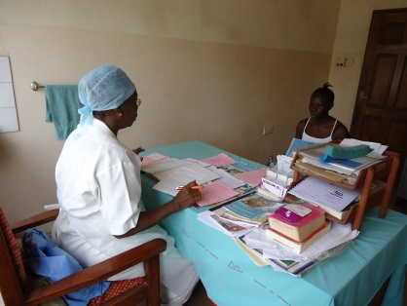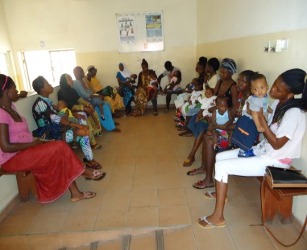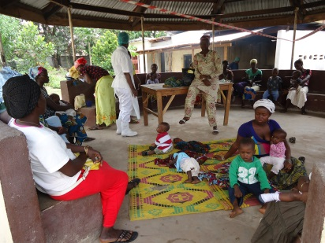

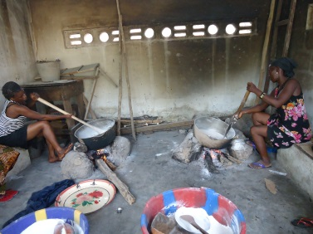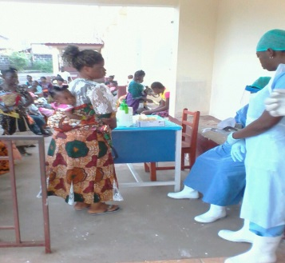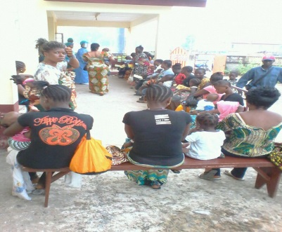

These pictures from Loreto clinic show the psychosocial nurse in one of the sessions, the reception area and parents of the under-fives program waiting and the preparation of the BenniMix for the children.

Holy Spirit Hospital has recently received a laboratory that will allow them to test for every virus including HIV, Hepatitis B and Ebola. A Team of Doctors and Scientists from Italy and Cameroon are here to train the Lab Technicians. They are offering what they call asero-survilance which enables them to establish whether antibodies found in an individual puts them at a higher or lower risk of Ebola depending on how long ago they were exposed to the virus. This will also help them in their studies of why some people who were previously exposed to the Ebola virus have ended up not getting ill, even though they have the antibodies in their system. More importantly Holy Spirit is now able to offer more services to the community as they are able to do thorough laboratory testing before doing invasive treatment. People are less afraid of going to hospital because now the risk of infection with Ebola while in hospital is much lower.

The Sisters program with the survivors has been very successful and we are currently working with 100 families. Our carers continue to identify families within their communities who are then referred to join the groups. They meet every month where they take part in group therapy and afterwards they are given a food parcel to take home with them. Trocaire have continued to fund this program which we started with your very generous donations. This funding comes to an end this month and these families have really appreciated all the support that they have been receiving over the months. For many of them, this is the only support that they have been receiving since the virus affected their communities. They are now very worried as to what to do when this help ends because they have no other source of help. Trocaire has also donated a mattress to each of the families as well as solar radio, charger and torches. Many of these families had infected people taken from the house and others had died in these houses. When they returned home they found out all their belongings had been burned and some were compensated with little or nothing. These new mattresses and beddings will help them as they try to rebuild their lives again. We have recently had a discussion with Trocaire about how they may be able in some way to help these families become self-sustainable. Here is a lorry load of 100 mattresses arriving last week for the affected families.

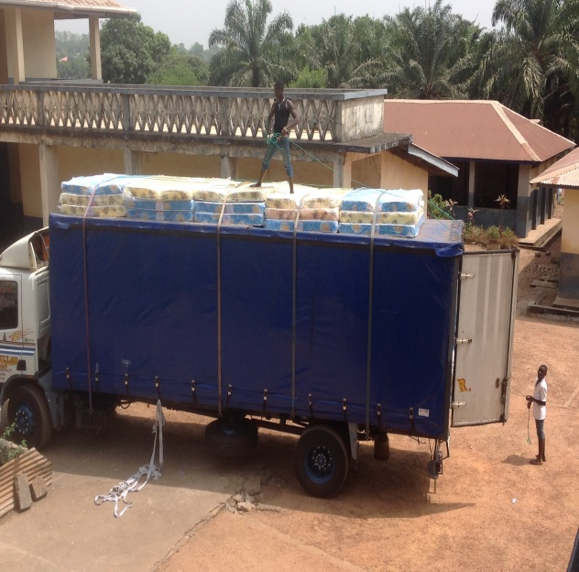
It seems like a dream now, as at the last meeting they were in near despair as to how they could feed their families next month. One lady who is Guinean and her husband that died was Sierra Leonean was particularly distressed. She is looking after her own two children but has also adopted a 15yr old boy from her neighborhood. His parents died and have no family to look after him. She too doesn’t seem to have any in-laws that will help her and she doesn’t have family to go back to in Guinea. She doesn’t know what to do because the business she had of selling items from Guinea can’t go on as she has no money at all. Once our food supplies end, she has no other source income to feed her children. She has now been introduced to Loreto Clinic where one of her children can get onto the under-fives feeding program but she will need to find a way to feed herself and the other children. She is the one in the orange top. The second lady too is from Guinea and she too lost her husband but unfortunately her in-laws are not supportive of her. When she suggests that she could go back to Guinea, they tell her that she can’t take her children. So she is torn between leaving her children and getting support from her family. She is staying for now as she doesn’t want to leave her children. She too was selling items from Guinea and is struggling to get herself started again as she has no capital at all. These are just some of the desperate situations that some of the survivors are facing after Ebola.

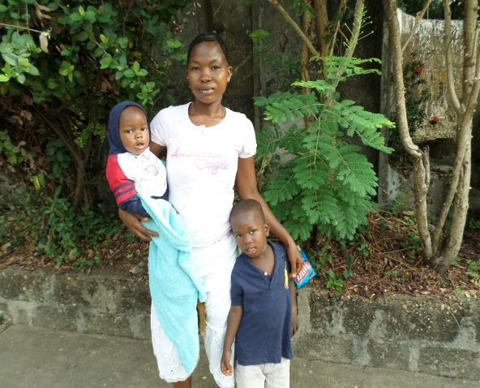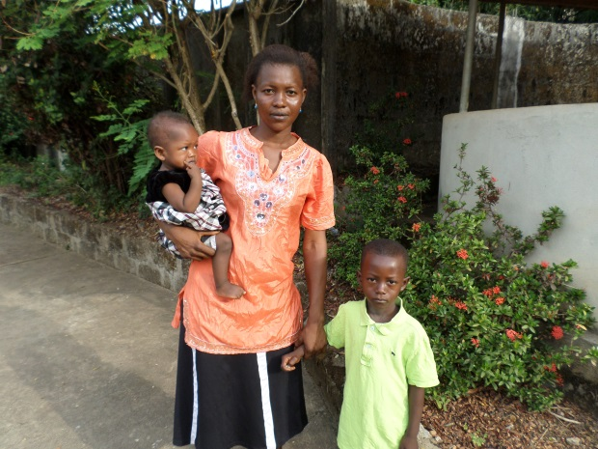
One of the first survivors we started working with and was highly pregnant at the time (Aminata) had a lovely baby boy Samuel on the 31st December. Some of you may remember the photographs of her children receiving the Christmas gifts in the near collapsing house. We got quite a fright recently when she had to be admitted to hospital and they thought an operation would be necessary. Thankfully after a few days in hospital and a course of antibiotics she is now on the road to recovery. Aminata and her husband’s second wife Marie get on really well. When she was in hospital, Marie breast fed Aminata’s baby for her. This practice is very common in Sierra Leone especially where babies are orphaned and are looked after by the grandmother or another nursing mother. Her house is also now being restored and a new roof being put on it, thanks to the generous donations from Ireland.

You have no idea of the impact of your generosity in uplifting the spirits of these good people. We as the Sisters receive all the thanks but as they say here, we are only “the Sababo” which means the intermediary. Because of you we can meet so many critical needs with the money that you send us. We are so grateful for your kindness. Here is Aminata, her new baby and the new house under construction where the two widows and their 13 children will be living.

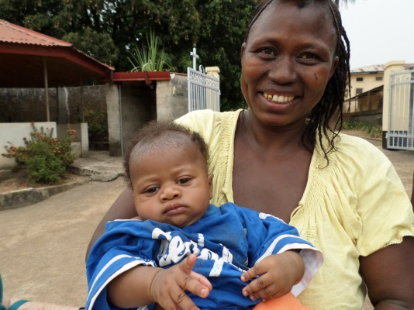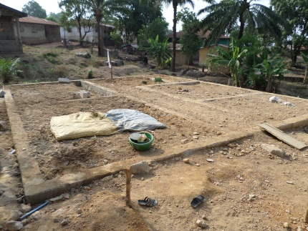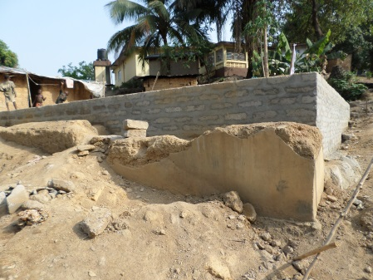

Here at the school, we’re happy to inform all our donors that our boys and girls who entered for NPSE - National Primary School Exam, were among the highest achieving pupils in the main stream St. Joseph’s school. We are also very proud of our eight secondary students as well as Finda one of our teachers who spent six weeks in Freetown where they did two modules in IT and they all did very well. This was funded by Irish Aid and we had the honor of the Irish Ambassador Dr. Sinead Walsh presenting them with their certificates. The founder and director of the Dorothy Springer Foundation is Dr. Abs Dumbuya whose aim is to enable people living with disability to achieve employment by their skills in IT. We’re very grateful for the continued support from Irish Aid. They’re now back and are ready to do their Junior Secondary exams. Abdul Rahman is attempting the Senior Secondary exams. Here are some pictures of our proud graduates.

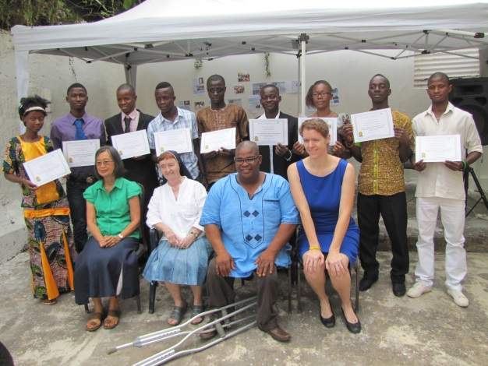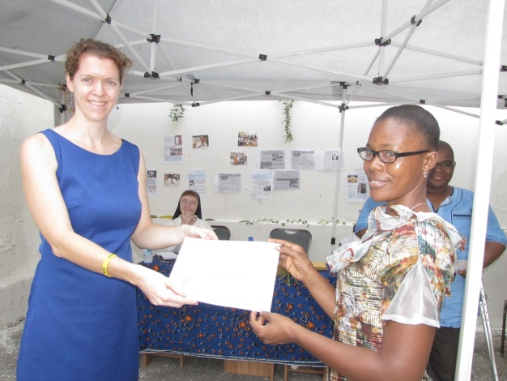

Monica who is the school’s audiologist and lecturer arrived from England on the 4th March. She has been coming to the school for the last 10yrs and has supported the development of Special Education at UNIMAK and at the school. During that time the Audiology Department has trained teachers and provided hearing aids adapted to the needs of the children. Catherine Healey is our other lecturer from Birmingham University. She hopes to join us at the end of this month. Together they make a professional team and hopefully our teachers will be graduating next February with Diplomas and B.Ed. One of the families benefiting from Monica’s expertise is a boy and a girl that are Ebola survivors. They lost their hearing after having endured and survived the Ebola Virus Disease. Monica has been assessing them to see how best we can support them here at the school and more than likely they will be boarding with this. This is because their main carer is their elder sister Nene who is now pregnant and also looking after six other siblings. Here they are during one of their visits.

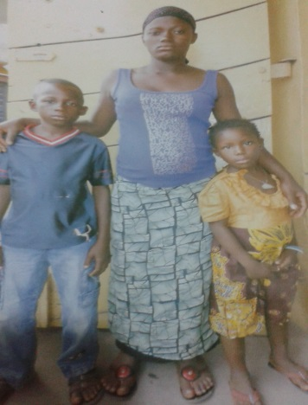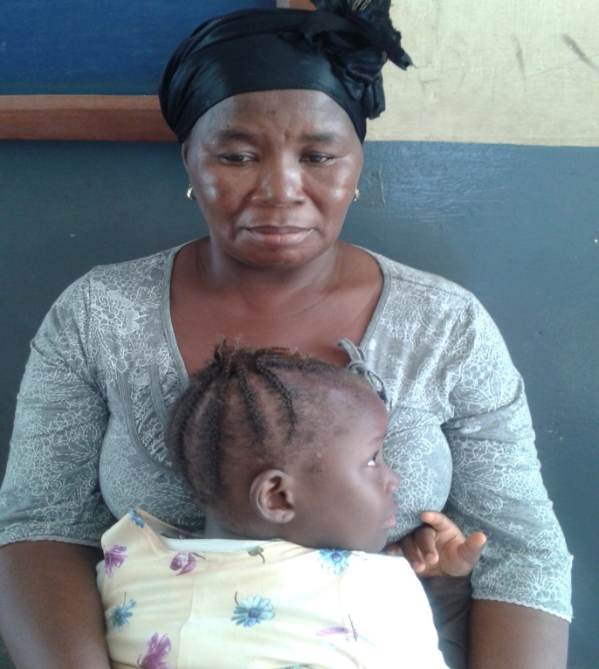

We continue to receive regular updates on the progress and preparation of the container being packed by St. Anselms and Friends of St. Joseph’s is making. This is very exciting news. We continue to hear of the overwhelming generosity and hard work that everyone is putting into making sure that it arrives here. You really do love St. Joseph’s! We have a group of students who finished their carpentry, sewing and catering certificates that are waiting with eagerness for the tools, machines and equipment. The container will on its arrival be used as a business entrepreneur practice for our students. KNNS who are an Irish network company currently working to set up the fiber optic network in Sierra Leone, have also very kindly donated electrical equipment that was on our wish list and will be arriving soon in their container. They also provide us with internet connection at the school and are always ready to come to our aid when technical support is needed as well as monetary donations.

Thank you very much for your continued support to St. Joseph’s and for being with us during this difficult journey that our country is going through. Your prayers love and support (financial and emotional) has made this journey bearable. We cannot thank you enough for all you have done and continue to do. We will continue to pray for you and keep in touch always.

Love and prayers,
Sr. Mary and Mercy

